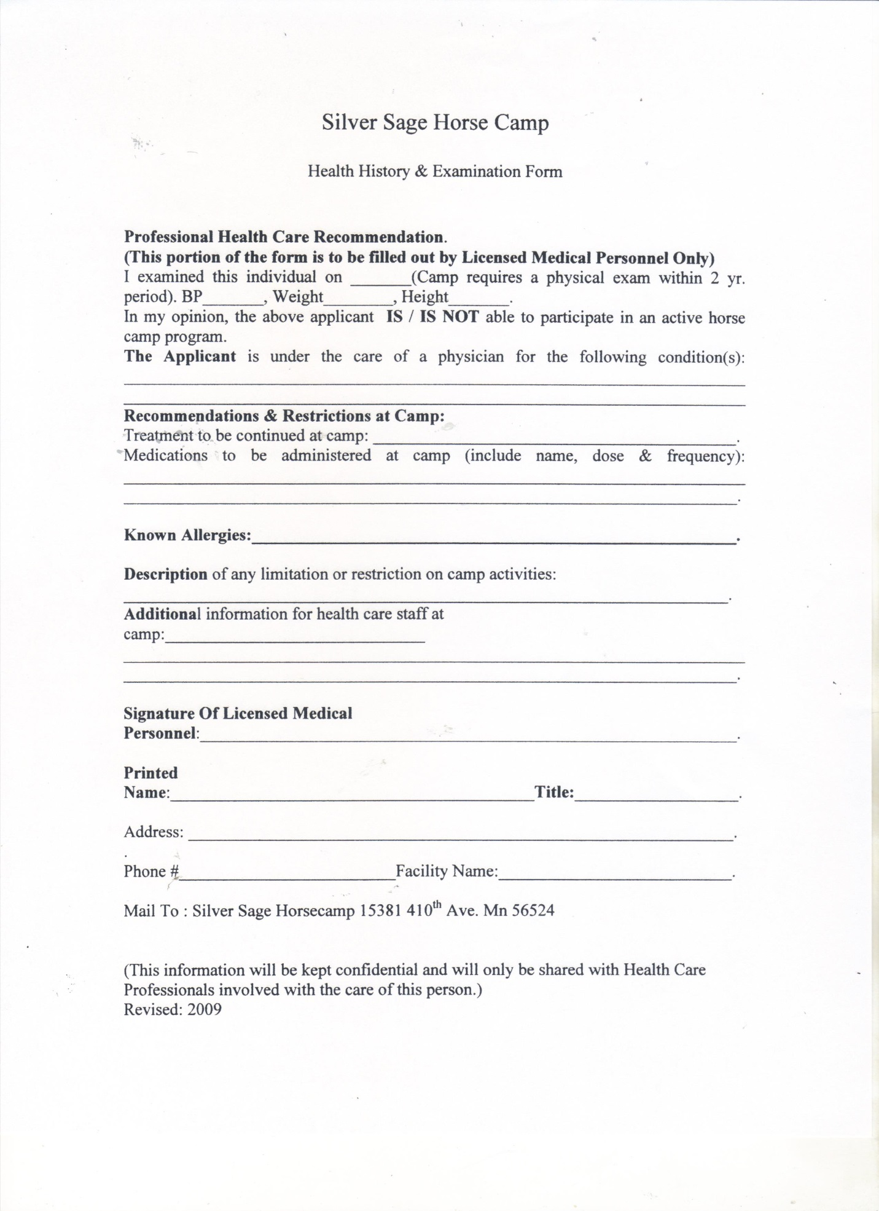
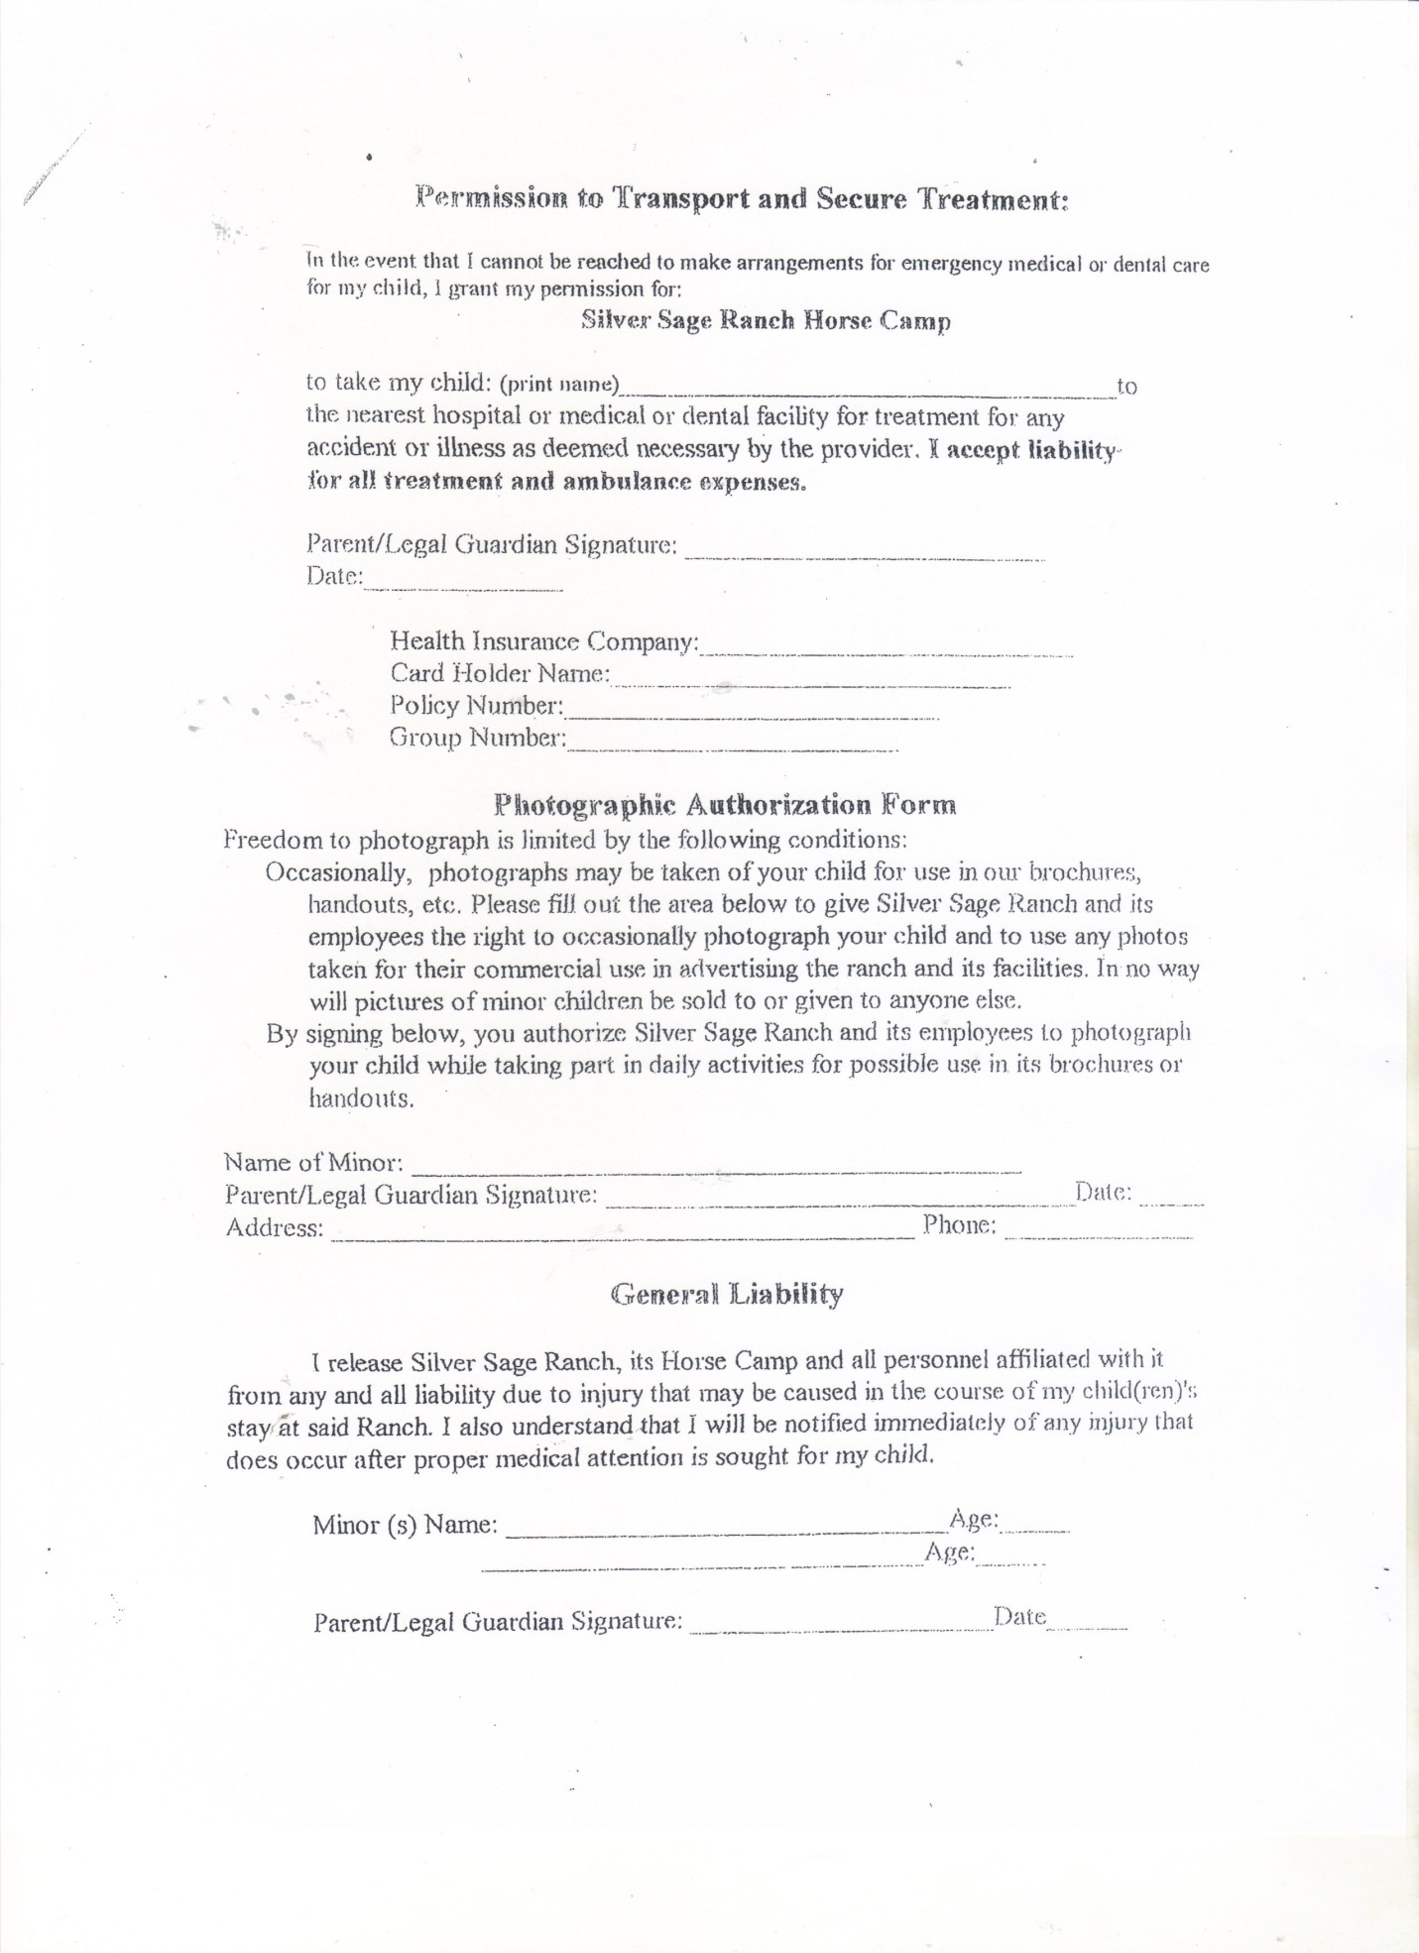
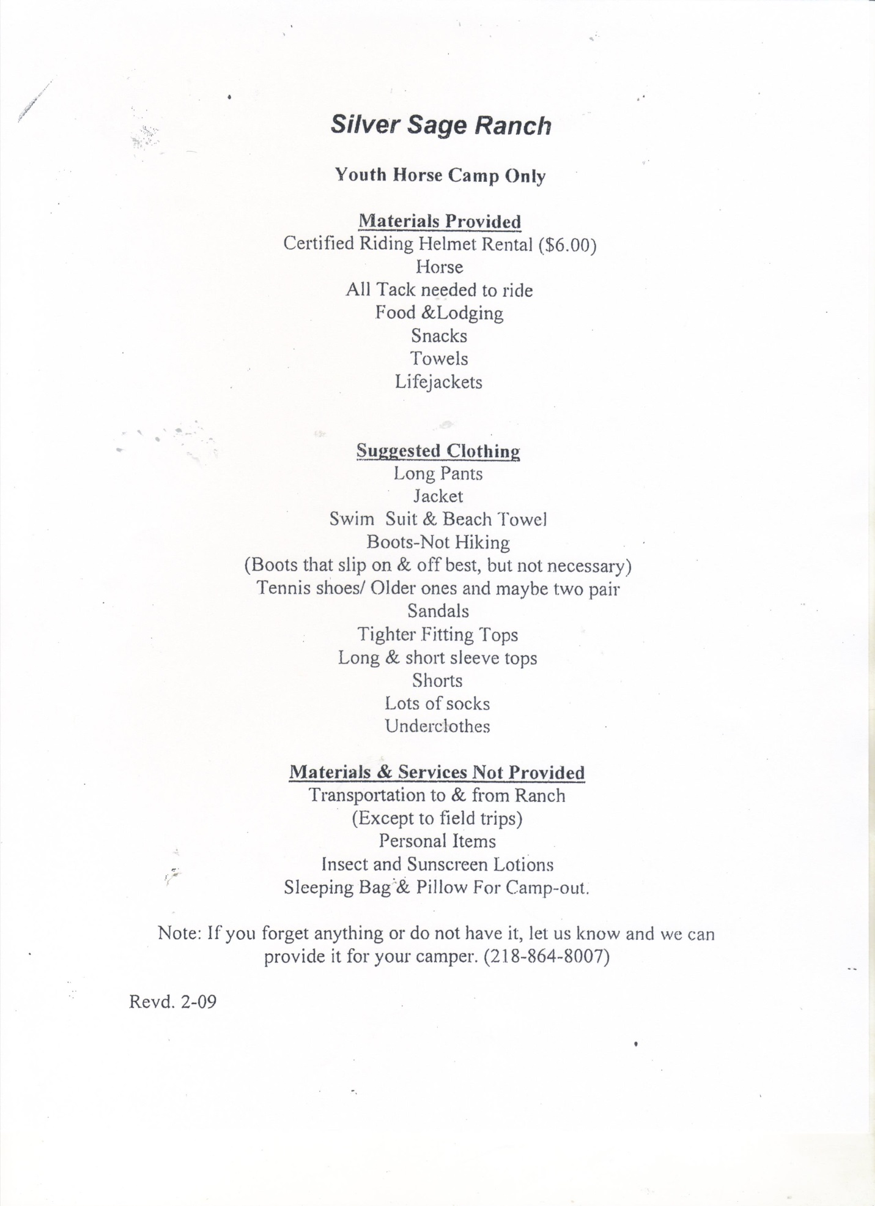
SILVER SAGE YOUTH HORSE CAMP
2021 Summer Schedule
15381 410th Ave Clitherall, MN 56524
218-864-8007

*Please Notice Deadline for Registration April 1st, 2021
Week Long Horse Camp: Check in Sunday after 6:00 pm /Or Monday 8:00am
Pickup & Horse Show 4:00 pm Friday.
Schedule of weeks:
Week # 1 June 6th-11th, 2021 Cost $550.00
Week # 2 June 13th-18th, 2021 Cost $550.00
Week # 3 June 20th-25th 2021 Cost $550.00
Week # 4 July 11th- 16th, 2021 Cost $550.00
Week #5 July 25 - 30th, 2021 Teen Week( 13 or older ) $550.00
*Receive 10% discount for new referrals & Second family member (Be sure To Let us know)
Day Camp: can be scheduled June 1st-August 13th. Call for available day or days.
Held Monday –Thursday 8:00am -4:00pm $90.00/day
*Receive 10% discount for new referrals & Second family member (Be sure To Let us know)
____________________________________________________________________________
Registration Form:
Name: ____________________________________________________________ Address:____________________________________Town______________State______
Zip Code__________
Age:_______Gender:________ Phone:______________ Experience: None Some Exp.
Camp Date Choice:______________________Alternate Choice:_________________________
Parents Signature____________________________Print:____________________________________
Deposit $200.00 to Save Your Camp Date. _________ Deposit $____________Bal.Due:$________________

Deadline to register April 1st, 2021
Arrival is on Sunday after 6pm, or Monday morning at 8:00am. Arrangements may be made for Sunday 6pm registration, and or Monday morning. Whichever is convenient for you. But, be sure to let us know. Everything you camper needs is provided except their personal things. We do go for a treat to town, which is provided. If camper wants extra, you may send along spending money.
Safety is a paramount at the Silver Sage Ranch & Horse Camp, However participation in camp and horse activities has inherent risk and injuries sometimes occur. With enrollment, parents acknowledge and except this and agree to hold harmless the Silver Sage Ranch and its employee and owners against any claims, damages and or injuries. A copy of the liability form and health forms will be sent with confirmation of your deposit, to hold your reservation date..Forms & Balance of payment: Full Week Camp: Need two weeks before coming to camp. One day horse camp pre pay one week.

